BACK TO MAIN TOC

Summary and Conclusions

Summary
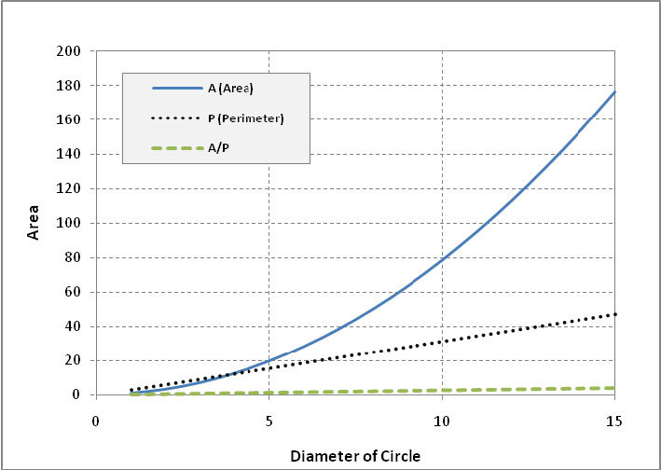Array
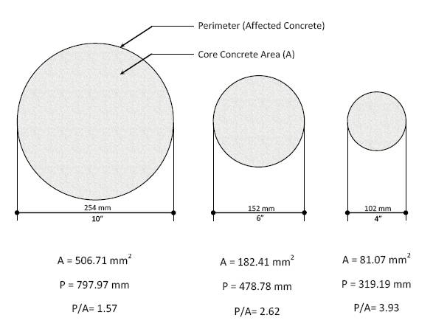Array

Conclusions

Suggestions for Future Studies

See Also
Place text here.

