RP Schmitz
This paper was written for and presented at the 17th Analysis and Computation Specialty Conference held in conjunction with the 2006 ASCE Structures Congress held in St. Louis, MO
ABSTRACT

INTRODUCTION
BACKGROUND
Concrete International
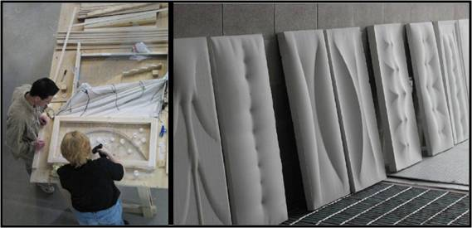Array
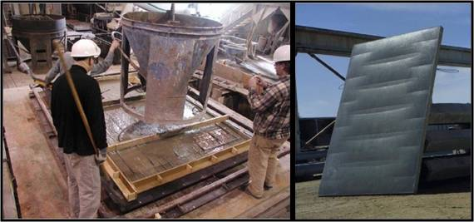Array
Proposed Design Procedure

ANALYSIS METHODOLOGY AND MATERIALS
Finite Element Analysis (FEA) Model Development
The Fabric Model and Material Properties

- R
Material Properties of Geotextile Fabrics
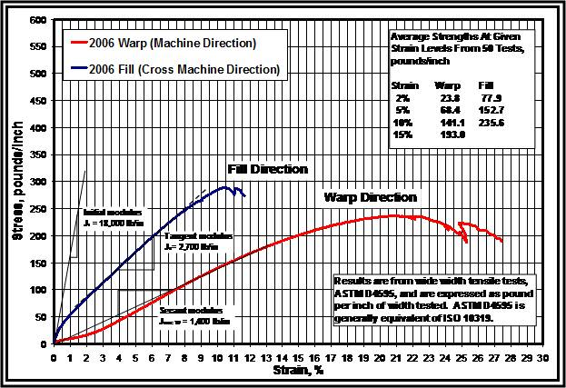Array
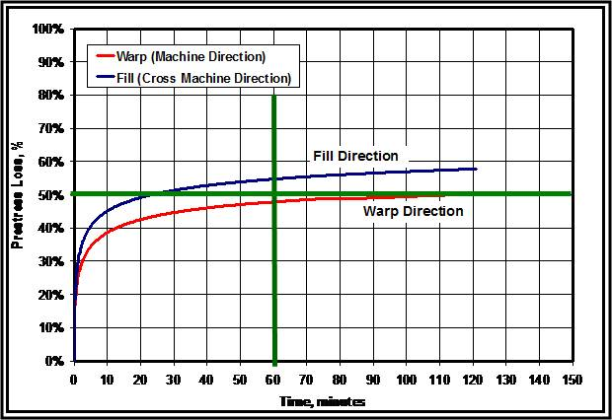Array
TABLE 1 | AMOCO 2006 GEOTEXTILE FABRIC MATERIAL PROPERTIES
t = 0.03-in | Fabric thickness
Ewarp = Ea = 46,667 psi | Modulus of Elasticity, Machine Direction
Efill = Eb = 90,000 psi | Modulus of Elasticity, Cross Machine Direction
G = 23,333 psi | Shear Modulus
v = 0.0 | Poisson's Ratio
Relaxation and Creep in Geotextile Fabrics
ANIMATIONS
ADINA Fabric Model
ba
aaa…………………
bbb…

a
b
a
b
The Slurry Model and Material Properties
TABLE 2 | SLURRY MATERIAL PROPERTIES
t = varies-in | Slurry thickness
E = 2 psi | Modulus of Elasticity
vsm = 0.0 | Poisson's Ratio
wtsm = 145 lbs/ft3 | Weight
Dsm = 0.00021716366 lb-sec2/in4 | Density

PANEL DESIGN AND OPTIMIZATION

Step 1 – Determination of Load Paths
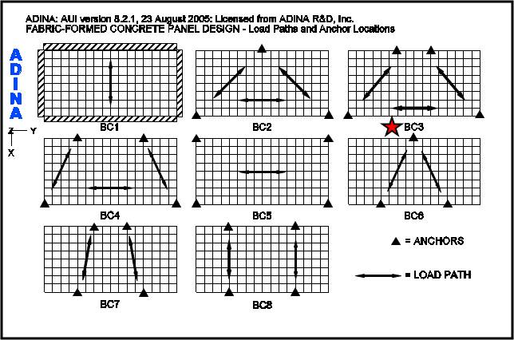Array
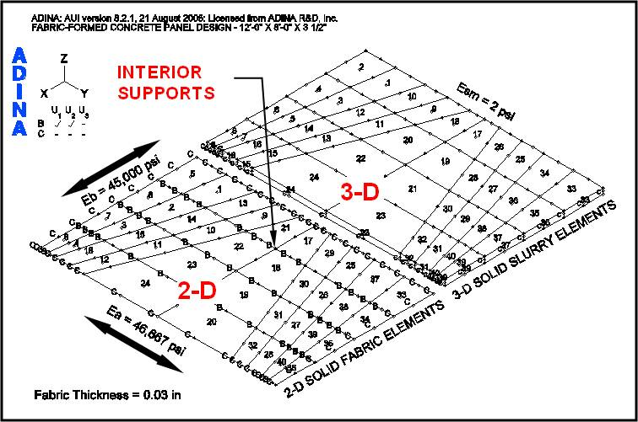Array
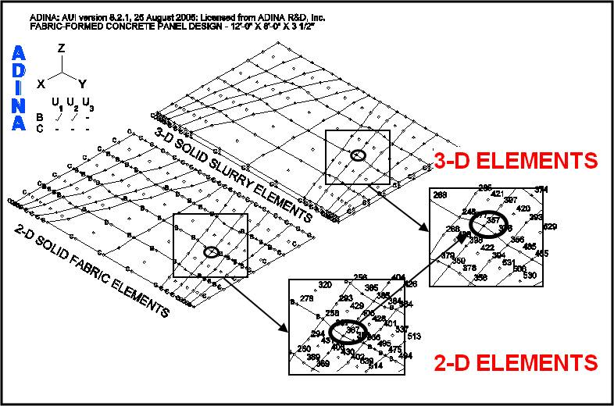Array
Step 2 – Define Fabric Formwork Design
“B”
Step 3 – “Form finding” the Panel Shape

ANIMATIONS
Step 4 – Panel Analysis and Design
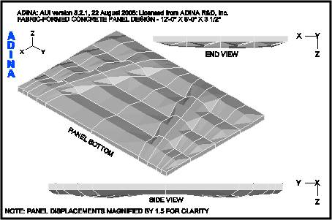Array
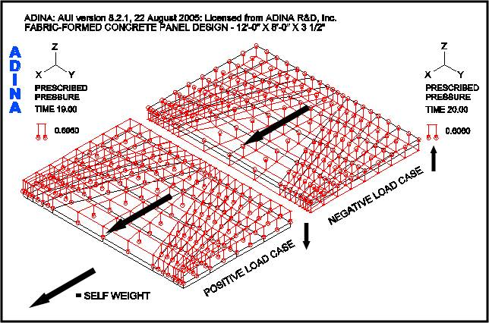Array
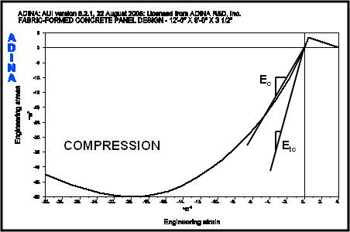Array
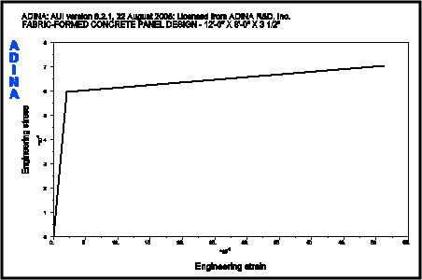Array
uDc………………………
uW………
c
uD
uW
TABLE 4 | CONCRETE MATERIAL PROPERTIES |  | TABLE 5 | REINFORCING MATERIAL PROPERTIES
t = varies-in | Concrete panel thickness |  | Es = 29,000,000 psi | Young's Modulus of Elasticity
Ec = 4,074,281 psi | Secant Modulus of Elasticity |  | Ets = 290,000 psi | Strain hardening (Tangent) Modulus
Etc = 7,129,991 psi | Initial Tangent Modulus of Elasticity (Assume 1.75 x Secant Modulus) |  | fy = 60,000 psi | Initial yield stress
f΄c = 5,000 psi | Compressive strength of concrete (SIGMAC) |  | Ds = 0.0007339 lb-sec2/in4 | Density
εc = 0.002 | Compressive strain of concrete at SIGMAC
f΄uc = 4,250 psi | Ultimate compressive strength of concrete (SIGMAU, assumed @ 85% f΄c)
εuc = 0.003 | Ultimate compressive strain of concrete at SIGMAU
fr = 5√ f΄c = 353.6 psi | Uniaxial cut-off tensile strength of concrete
νc = 0.20 | Poisson’s Ratio
wtc = 145 lbs/ft3 | Weight
Dc = 0.00021716366 lb-sec2/in4 | Density
Φp = 0.55 | Strength reduction factor for plain concrete
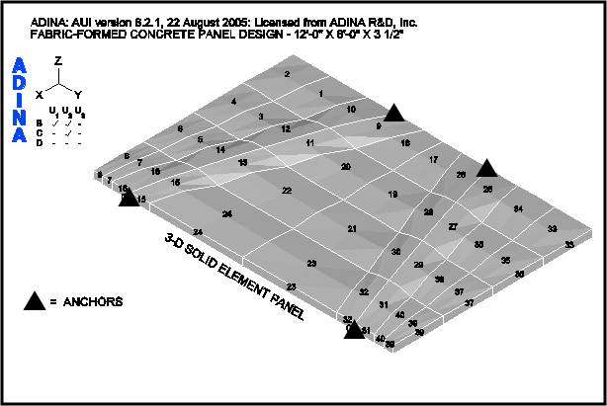Array
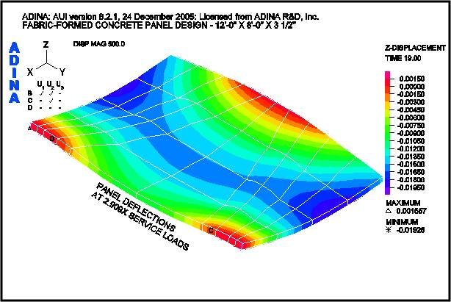Array
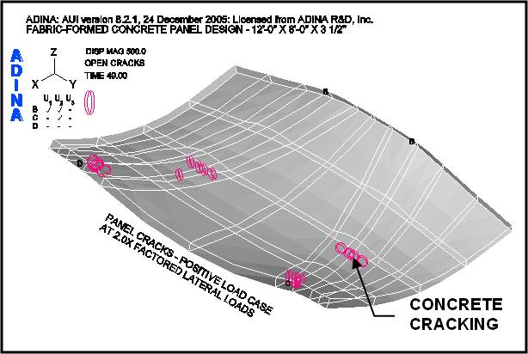Array
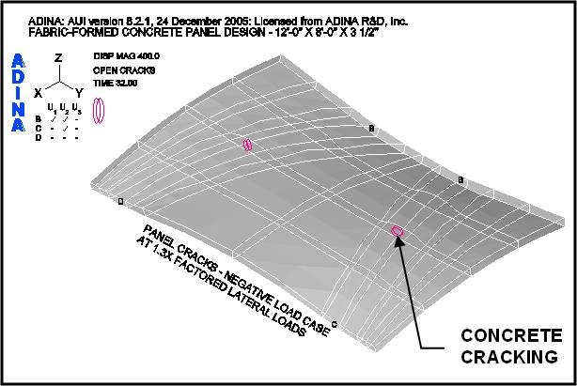Array
within the body of the panel
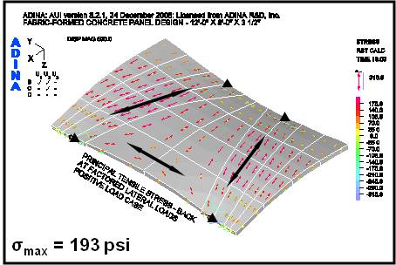Array
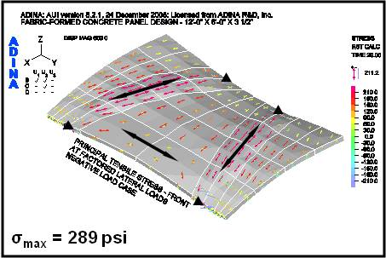Array
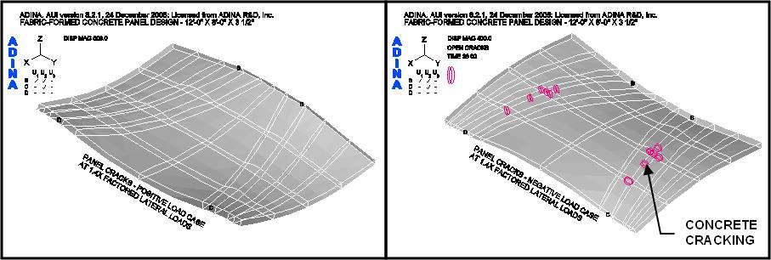Array
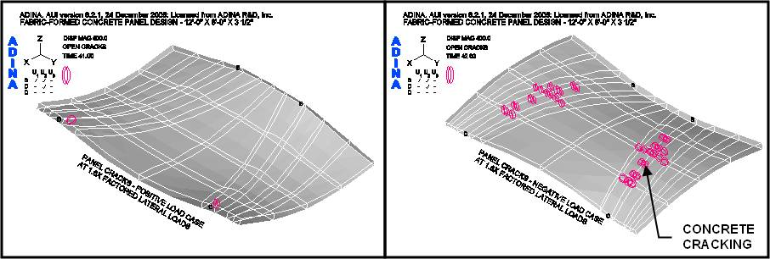Array
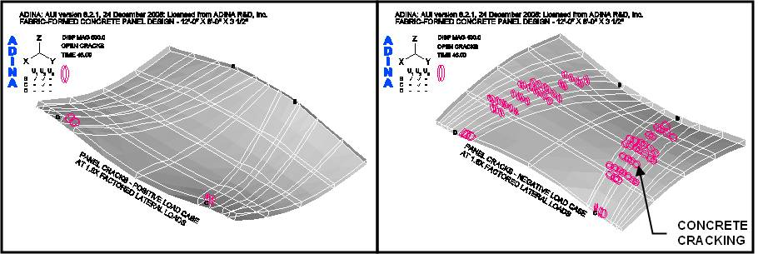Array
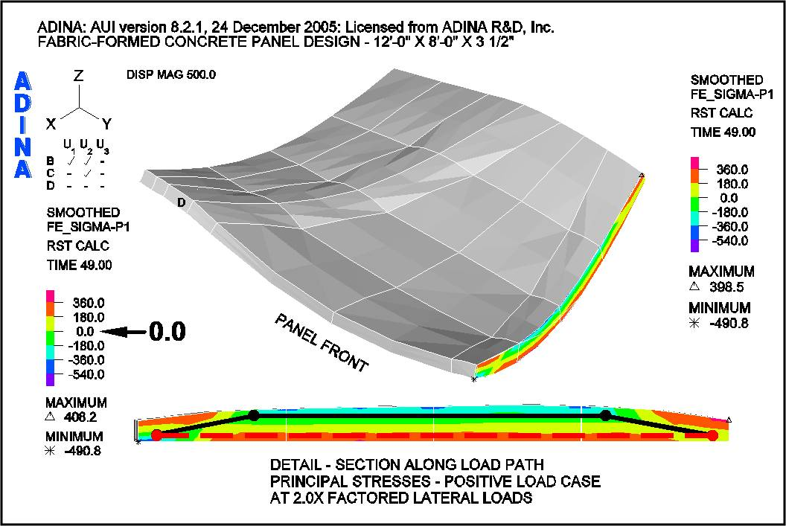Array
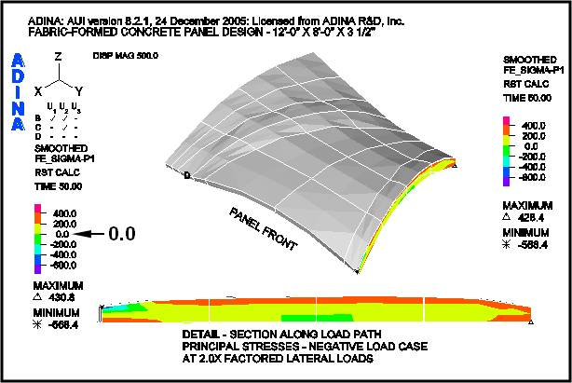Array
within the body of the panelANIMATIONS
Reinforcement Considerations
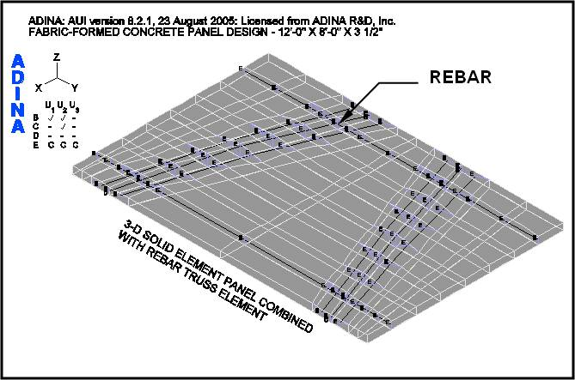Array

CONCLUSIONS AND RECOMMENDATIONS
Conclusions
Recommendations
ACKNOWLEDGMENT

See Also
Place text here.

References
Concrete International
Addresshttp://www.umanitoba.ca/cast_building/resources.html
Concrete International
ADINAAvailable
ADINA – Theory and Modeling Guide
Test Method for Tensile Properties of Geotextiles by the Wide Width Strip Method
Amoco 2006 Stress Strain
Geosynthetics International
Amoco 2006 Relaxation Results
Addresshttp://www.terram.co.uk

External Links
The Centre for Architectural Structures and Technology (C.A.S.T.)
Fabric-Formed Concrete

